**Illustration as a Shaper of Emotional Branding on Teh Botol Sosro Packaging for the 75th Indonesian Independence Day West Java and DKI Jakarta Edition**

Andri Setiawan1, Supriatna2, dan Enok Wartika3

Art Studies and Creation Study Program

Pascasarjana Institut Seni Budaya Indonesia (ISBI) Bandung

Jl. Buah Batu No.212, Cijagra, Kec. Lengkong, Kota Bandung, Jawa Barat 40265

[Andrisetiawan808@gmail.com](mailto:Andrisetiawan808@gmail.com)1, ekosupriatna@yahoo.com 2, [enok_wartika@yahoo.com](mailto:enok_wartika@yahoo.com)3

**ABSTRACT**

Teh Botol Sosro is the first packaged ready-to-drink tea in Indonesia. In celebrating Indonesia's 75th Independence Day, it launched a new packaging with the theme "Independence and Cultural Diversity of Indonesia". This research analyses the crucial role of the concepts and themes of independence and Indonesia's cultural diversity as significant factors in establishing an emotional bond with consumers. The research method employed is qualitative analysis with a visual communication methodology approach. Data was collected through visual analysis and expert interviews. The research findings reveal that the utilization of the concepts and themes of independence and Indonesia's cultural diversity in the packaging of Teh Botol Sosro for the 75th Independence Day edition, specific to West Java and DKI Jakarta regions, analyzed through Marc Gobe's four pillars, plays a vital role in building an emotional connection with consumers. It reminds consumers of national values and cultural diversity and adds a profound emotional dimension to the consumption experience. The interplay between the concepts, themes, and emotional branding is demonstrated to be complementary, wherein the incorporation of icons and symbols in the packaging effectively strengthens the emotional message conveyed by the brand.

*Keywords: Teh Botol Sosro, Packaging Design, Emotional Branding*

**ABSTRAK**

Teh Botol Sosro merupakan minuman teh kemasan siap minum pertama yang ada di Indonesia. Pada perayaan kemerdekaan Indonesia ke-75 tahun mengeluncurkan kemasan baru betemakan “Kemerdekaan dan Keragam Budaya Indonesia”. Tujuan dari penelitian ini untuk menganalisis peran penting dari konsep dan tema kemerdekaan serta keragaman budaya Indonesia menjadi faktor yang signifikan dalam upaya membangun ikatan emosional dengan konsumen. Metode peneltian yang digunakan adalah analisis kualitatif dengan pendekatan metodologi komunikasi visual. Data yang dikumpulkan melalui analisis visual, wawancara ahli. Hasil penelitian menunjukkan bahwa penggunaan konsep dan tema kemerdekaan serta keragaman budaya dalam kemasan Teh Botol Sosro edisi Hut RI ke-75 Edisi Jawa Barat dan DKI Jakarta, dianalisis melalui empat pilar Marc Gobe ternyata memiliki peran dalam membangun ikatan emosional dengan konsumen. Tidak hanya mengingatkan konsumen akan nilai-nilai nasional dan keragaman budaya, memberikan dimensi emosional yang mendalam dalam pengalaman konsumsi. Hubungan antara konsep, tema, dan emosional branding terbukti saling melengkapi, di mana penggunaan ikon-ikon dan simbol-simbol yang dibawakan pada kemasan mampu memperkuat pesan emosional yang ingin disampaikan oleh merek.

Kata kunci: *Teh Botol Sosro, Desain Kemasan, Emosional Branding*

**INTRODUCTION**

1. **Background**

The breadth of the current target market makes every producer must be able to compete to make the product attractive. Nowadays, product competition is not only at the level of quality or content of the product but also penetrates into the creative field in presenting the product so that it can reach consumers. Creative domains that were previously considered part of art are now starting to be taken into account in product business processes.

Packaging visualization is one of the parts touched by the creative sector, which is expected to help product development, increase sales, and become a medium of communication and information from producers to consumers. A long with this explanation (Sari, 2013) states that packaging is an essential element in building awareness and attractiveness and forming a product image.

Packaging is a result of the packaging process, which acts as a protector of a product. However, along with the rapid development of the trade industry, the advancement of material technology, and the presence of printing techniques, packaging, which was initially only a product container and facilitated the organization and distribution of products, is now starting to have a new function, which plays an essential role as a medium of communication and information for a product. In line with that, according to Sari, the packaging is referred to as the*silent sales man or girl*(Sari, 2013). because a package that communicates and provides information can represent and show the advantages of a product without a server.

A great amount of similar products competing in the same segmentation and target market makes the product marketing process even more difficult. Therefore, manufacturers must be able to highlight their products; one way that can be done is to make packaging as attractive as possible without letting go of the existing market share. This can be the main attraction to provide a different position from similar products. This statement is in line with that expressed by Klimchuk and Krosavec, four factors that improve packaging design, namely: Illustration (images, symbols, photos), color, structure or physical form, and typography (Klimchuk and Krasovec, 2007, p. 82).

The packaging design's attractiveness can influence the target audience's perception to be a differentiator from other products to provide positive results. In this case, consumers buy these products. Meanwhile, as a product image or brand image, packaging visualization aims to provide information and communication with consumers through designs designed by manufacturers so that they can impress consumers; Supriatna believes "packaging design can provide a persuasive effect creating an effective relationship that causes closeness between products and consumers" (Supriatna, 2021 p. 39).

Illustration is one of the strategies used as visualization in packaging design. Soedarso stated that "Illustration is a picture that is intended to describe a certain purpose" (Soedarso,1990). Indirectly, illustration combines graphic elements to illustrate, communicate, and provide information.

Illustrations are not only part of a work of art but can also act as a medium for product marketing; according to Achyar Riyadh in the interviews conducted revealed that illustration is part of the process of branding*,*namely the process of creating a corporate image on a product, as well as being oriented towards the final goal, namely as a medium to attract the attention of consumers. The point is that the illustrations are well-designed and aesthetic, but the primary purpose of it all is to advance the business, provide information, and appeal to consumers.

On August 17, 2020, Teh Botol Sosro launched a unique edition packaging design. Taking advantage of this momentum, Teh Botol Sosro presents the theme of Indonesian Independence by depicting the diversity of Indonesian culture through illustrations on 300 ml PET packaging. In this special edition, Teh Botol Sosro presents illustrations of various cultures represented in eight different packaging designs, one of which is the culture of West Java and DKI Jakarta, presented in one visual packaging.

.

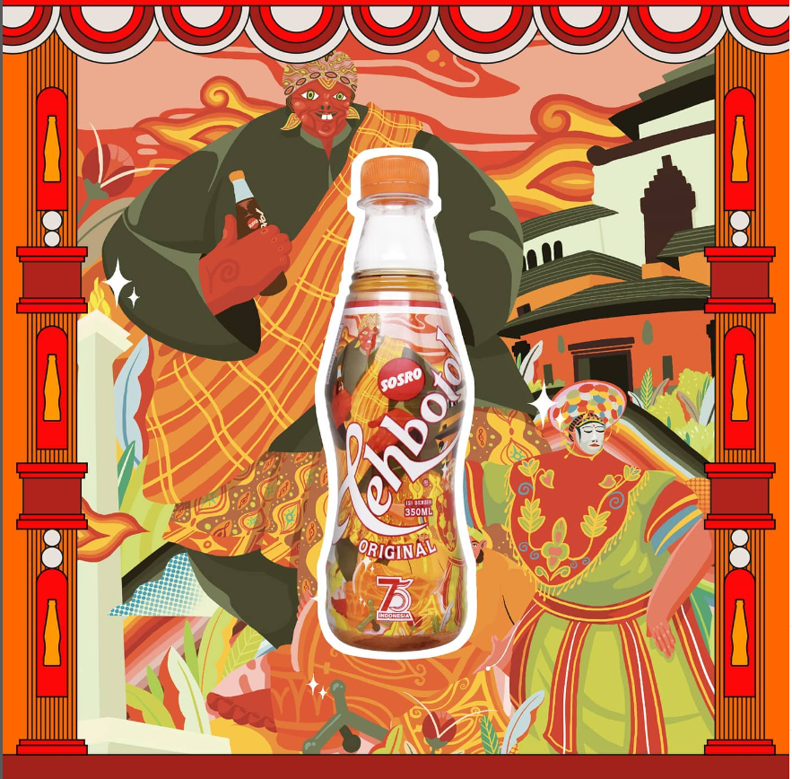

Figure 1. Visual of Teh Botol Sosro Packaging for the 75th Indonesian Independence Day, West Java and DKI Jakarta editions

(Source: Instagram Teh Botol Sosro)

The illustration Teh Botol Sosro Packaging for the 75th Indonesian Independence Day has many roles in its application. Not only as forming aesthetics but also as forming perceptions and emotional appeal to the product. Additionally, Supriatna explained, "Packaging designs that are designed aesthetically and according to design principles can create perceptions, likes and adapt at an emotional level and create loyalty" (Supriatna, 2021, pp. 39-42). From this explanation, it can be concluded that Teh Botol does not sell its products but sells the emotions attached to the packaging design that is tailored to the themes, concepts, and feelings that arise in the minds of consumers.

Based on the background described above, the researcher intends to analyze the illustrations of Teh Botol Sosro Packaging for the 75th Indonesian Independence Day West Java and DKI Jakarta edition formulation:

1. Why did this theme and concept appear on the Teh Botol Sosro Packaging for the 75th Indonesian Independence Day, West Java, and DKI Jakarta editions?

2. What is the stage of establishing an emotional closeness between consumers and the visual packaging of the Teh Botol Sosro Packaging for the 75th Indonesian Independence Day, West Java and DKI Jakarta editions?

The aims of this research are as follows:

1. Describe why the theme and concept are used.

2. Analyze the stages of forming emotional closeness between products and consumers.

The theory used in this research is the theory *of Emotional Branding*described by Marc Gobe (2005). Gobe ​​is a marketing expert and writer who developed the emotional concept *of branding,*which emphasizes the importance of emotions, experiences, and stories behind a story*,*which indirectly can build a stronger bond between products and consumers. According to Gobe, "emotional brandingrelated to sensory experience, a design that can make consumers feel the product, a design that makes consumers buy the product (Gobe, 2005:10).

*Branding*is a series of strategic processes or ways to build a positive image in the eyes of consumers. This definition aligns with what was expressed by Achyar Riyadh: "Branding is the process of creating a brand or the whole process of forming a brand *Image*of products or companies that have the ultimate goal of increasing sales. Deep process *branding*What can be meant are all instruments designed with mature concepts and ideas, including visual assets (graphic designs, concepts, themes, and all other instruments aimed at improving the product marketing process.

Nowadays, intense market competition makes the business atmosphere very different; every company is competing to create concept concepts and ideas within the realm *of branding*become very broad, so a concept or idea is needed that can quickly enter the minds of consumers. Gobe, in his book, argues that "in a very high market competition where goods cannot attract a new market or even retain existing clients, emotional brandingbe the answer.

Therefore, in order to create a design that can touch the emotions of a product, it does not only sell the contents of the product but also sells experiences and stories and focuses on aspects of desire and satisfaction that affect consumers' moods. Teh Botol Sosro has implemented this in the marketing process carried out in 2020 with a very different visual packaging. Packaging is the process of delivering information and communicating between products and consumers. Meanwhile, according to Gobe, "Communication becomes an emotional producing process*Branding*strong” (Gobe, 2005, p. 32). Based on the results of this background, indirectly, the emotional stages-brandingalready done by Teh Botol Sosro on packaging design for the 75th Indonesian Independence Day editions of West Java and DKI Jakarta.

The limitations of this research are as follows:

1. Fundamentally analyze why the themes and concepts are used on the packaging editions.
2. Analyze the emotional *branding*on visual packaging for the 75th Indonesian Independence Day editions of West Java and DKI Jakarta.

By using deep theory in the research, the researcher can understand the broader context and produce a deeper understanding of the phenomenon being studied.

**B. Literature Review**

Literature review is a study conducted on previous research that aims to find gaps or differences from previous research and can be used as a reference or reference in conducting this research. Based on the results of the literature review conducted, several previous studies related to this research were obtained, as for the previous research as follows:

The results of the first study entitled "Visual Review of The Botol Sosro Packaging Special Edition for the 75th Indonesian Independence Day" were carried out by Yana Erlyana and Bestymoria in an article published by the Visual Arts and Media Visual Communication Design Journal Vol.1, No.3, November 2020, p. 173-183, Bunda Mulia University. This study describes illustration as one of the visual elements used in designing the packaging for the Teh Botol Sosro special edition for the 75th Indonesian Independence Day. The discussion in this study is that only the cultural codes in each illustration

can form information that can be digested accurately. Moreover, the illustration relates to the lives of individual Indonesians whose voice is collected based on nationality. Equity, knowledge, culture, and history. Discusses the visual appearance of bottles without any meaning or use of signs that are studied in more depth. The use and selection of objects as symbols in each illustration is quite good.

The research conducted by Erlyana and Bestimorla (2021) have similarities in the object of research; it is just that the research conducted by Erlyana and Bestimorla was carried out on the entire packaging of the 75th Indonesian Independence Day, which totaled approximately eight packages, while the one carried out in this study totaling one package with two visualizations of different regions, namely West Java and DKI Jakarta. Furthermore, in previous studies, the discussion was only carried out on visual displays without discussing the more profound role of illustration.

The second research, "Visual Elements of Packaging as a Product Communication Strategy," was conducted by Ni Luh Desi In Diana Sari and was published in the Prophetic Journal Vol. 6, No. 1, April 2013, p. 43-52. This study explains that the visual elements on the packaging are constructed as a means of product communication in the market. The visual elements on the principal display panel (PDU) consist of primary and secondary designs. This study discusses the visual elements of whatever is on the visual display (PDU) in the package. In this study, Willbur Schramm's communication theory describes the communication process of packaging elements as a primary stimulus to attract the audience's attention.

The research conducted by Sari (2013) can be used as a reference for ongoing research; this is related to how visual elements, especially illustrations, can become the main attraction in the product interaction process with consumers. However, there will still be differences between the previous and current research. In addition to product differences, the visual communication process flow discussed will also differ. introducing Sundanese figures, coloring illustrations can help train fine motor skills in children because, at that age, well-stimulated motor development can develop more rapidly.

Research conducted by Riyadh and Friends (2022) discusses how an illustration can play a role in reintroducing the Sundanese cultural character, namely the Punakawan to children aged 4-6 years. With an approach, Proper illustrations can also help develop a child's sensory motor skills. This previous research is used as a reference by researchers in analyzing the wider role of illustrations in product packaging.

The research conducted by Lestari, Santosa, and Suharno (2022) with the title "The Role of Indonesian-Themed Illustrations in Beverage Products on Consumer Emotional Responses" in this study discusses how an Indonesian-themed illustration and local packaging can influence consumer emotions. The method in this study uses a combination of qualitative and quantitative methods where literature and questionnaires are used for the data collection process. The use of packaging design theory, as well as Rolan Barthez's semiotics, is used for consumer interpretation of related illustrations.

The research by Lestari and friends, there are similarities regarding how illustration can play a role in the attractiveness of consumers seeing a product. However, the object of this study is different; previous research was conducted on good coffee packaging, while this study used the Teh Botol Sosro drink object. In addition, there are different methods and theories, so there are still gaps or differences in this study. Through the results of previous research, the author will analyze the visual packaging of the Teh Botol Sosro Packaging for the 75th Indonesian Independence Day, West Java and DKI Jakarta editions describes what visuals are designed in the packaging and knows the process brandingon the packaging.

1. **Research methods**

The research method is a procedure used to find data supporting scientific research. This study used qualitative methods. Qualitative research aims to describe and interpret the object under study according to the actual situation. According to Sugiyono, “Qualitative research can be regarded as naturalistic research because the research is conducted in natural conditions *(Natural setting)”*(Sugiyono, 2016, p. 8)*.*A natural setting means the researcher does not manipulate the object under study. Qualitative research is more descriptive, namely research emphasizing the data collected. The data collected does not have a numerical load.

To assist and facilitate the analysis of the visual content contained in the Teh Botol Sosro packaging, a visual communication methodology approach is used, which consists of four stages that will be carried out:

* + - 1. Description identifies seeks information from works without interpretation and opinion.
      2. The analysis discusses the visual elements displayed with opinions and arguments.
      3. Interpretation of the process supported by the first two stages to strengthen arguments and accuracy in interpreting the work.
      4. Assessment at this stage how a work can have its uniqueness and privileges in the eyes of consumers or audiences.

**1. Data Collection Techniques**

Data in research is one of the essential variables that can help the accuracy and validity of this research. Then, appropriate steps are needed

to collect existing data. Interviews, Observation, and Literature Study carried out the data collection techniques in this study:

*Interviews*are conducted to obtain more in-depth data, conducted with experts who are competent in a field, both academics and practitioners. According to Sugiyono, interviews are conducted if you want to look for preliminary studies and more in-depth data with a small number of respondents (Sugiono, 2016, p. 137). This study conducted interviews with experts in fields related to this research. The sources are :

* 1. Mr. Achyar Riyadh, M.Sn Dean of the Faculty of Science and Technology, University of 'Aisyiyah Bandung.
  2. Mr. Candra Pratama Dewa is an illustration designer practitioner for the design of the Teh Botol Sosro packaging for the 75th Indonesian Independence Day editions of West Java and DKI Jakarta.

Observation is the process of observing the object of research directly. In line with this Sugiono stated, "Observation has specific characteristics, namely direct observation of spaciousness, not limited to people but also including other natural objects, and supported by facts from interviews" (Sugiyono, 2016, p. 203). Observations in this study were carried out on the packaging object that focuses on visualization of Teh Botol Sosro packaging for the 75th Indonesian Independence Day editions of West Java and DKI Jakarta.

Literature Study is a way of collecting data by studying the problems studied through scientific papers, books, and reports that can support the course of research.

1. **RESULTS AND DISCUSSION**
   * + 1. **Momentum of Independence**

The euphoria of Indonesian independence is an emotional and social experience that every individual in the Indonesian nation can feel. Indirectly, euphoria refers to feelings of joy, positive enthusiasm and pride (pride to be Indonesian, pride in Indonesia's natural wealth, and pride in Indonesia's diverse culture). Not only do individuals celebrate this momentum, but companies have the right to participate in this kind of celebration.

On August 17, 2020, several products took part in celebrating independence. In addition, the momentum of independence can be well integrated as a strategy branding by creating special edition packaging that can attract attention and create a powerful emotional bond. Some of the products that come with special edition packaging are the special Sector Key packaging for the batik edition as a form of pride in being an Indonesian woman, Pepsodent special edition #MerdekanSenyum, and the design packaging Teh Botol Sosro packaging for the 75th Indonesian Independence Day

In addition, it also coincided with Indonesia's independence day. BI (Bank Indonesian) issued a special edition of money with a nominal value of seventy-five thousand rupiahs. According to BI Governor Perry Warjiyo in the Kompas article, "Indonesia's 75-year momentum we must grow independence to build optimism and enthusiasm in achieving independence.

More than fifty years is a very long time for products and companies to develop and survive amidst the onslaught of similar products circulating in the market. Quality must be maintained, take advantage of every opportunity, and be flexible towards change. One thing that was done through this momentum was that Teh Botol Sosro presented a different packaging. According to Sabrina Kharisanti, Chief Marketing Officer of PT. Sinar Sosro said, "The packaging for the 75th Indonesian Independence Day edition is an expression of gratitude, a sense of gratitude to the nation and people of Indonesia, a sense of pride in Indonesian culture".

It is essential for Teh Botol Sosro to take advantage of every moment as an opportunity; special edition packaging adds value to product aesthetics but strengthens emotional connections with consumers and shows product and company commitment to national values ​​can create a new image related to the product or the company from Teh Botol Sosro. In the end, the community or consumers not only enjoy the drink from Teh Botol Sosro but can also feel the trust and generate loyalty to the product.

* + - 1. **Visual culture in the Packaging Teh Botol Sosro  the 75th Indonesian Independence Day editions of West Java and DKI Jakarta**

Apart from the independence momentum, which was used as the big theme on the day the product was launched with the Republic of 75th Indonesia Anniversary edition packaging. Teh Botol Sosro was able to see opportunities and phenomena of the visual culture of Indonesian independence, which became creative concepts in the process of process branding. Visual culture is created from visual-based information and communication media (through the senses of the eye) and can impact the audience who sees it. According to Dr. Setyo Budi, M.Sn (2021), in line with this explanation. “Visual culture is a new culture born from awareness " Psycho Visual Aesthetic". Budi explained an example in the presentation of the subject: when someone sees, reads or watches something without realizing that the spectacle permeates their subconscious and lives in that subconscious. Indirectly, from this explanation, it can be said that everyone has an imagination in the subconscious, and there is an emotional connection in their hearts through what they have seen so far.

The progress of civilization and technology is developing very rapidly, making much reading and viewing and entering foreign cultures; these cultures enter through television, the internet, social media, comics and other visual media. Indirectly, it can erode local culture in Indonesia. In line with this explanation, Harmoko, Agustin, Martha, and Alfianto argue that “the entry of foreign cultures into the country is a negative impact of easy access to technology, and can reduce the sense of nationalism of the younger generation” (Harmoko etc. al, 2022).

The phenomenon of the development of a visual culture has developed and entered all levels of society. Various kinds of brands utilize many opportunities in making the marketing process, forming positioning of a product or company in the minds of consumers. In line with this, Klimchuk and Krasovec argue that "changes in packaging design are a strategy used to reposition in attracting new target markets without losing previous target markets"(Klimchuk & Krasovec, 2008, p. 44).

Whether realizing it or not, the visual culture poured into product packaging strengthens the emotional bond between the product and the consumer. The following products have used the strategy of branding utilizing issues and phenomena of visual culture in society.

1. Rokok Djarum Coklat Anugerah Alam Indonesia - raises environmental issues and tourism in Indonesia and targets a new market segment, namely young people.
2. Indomie Tempoe Doeloe – generates memories or memories that exist in consumers.
3. Silverqueen Valentine edition – form that chocolate is an expression of affection
4. McDonald BTS Meals – targeting the fanaticism of K-pop fans in Indonesia.
5. Teh Botol Sosro Packaging for the 75th Indonesian Independence Day – proud of the diversity of Indonesian culture.

Each product has its aims and objectives in presenting visual culture in its packaging. Including Teh Botol Sosro Packaging for the 75th Indonesian Independence Day West Java and DKI Jakarta editions, presenting cultural elements and symbols of Indonesian independence in the illustrations. According to Dewa, "The several forms of Indonesian cultural diversity described are as follows: Cepot, Megamendung Batik, Monas, Betawi mask dance, drums from Sundanesse". According to Supriatna, "In Indonesian archipelago packaging design, as a product, it must be able to bring out the uniqueness, characteristics and identity of the area" (Supriatna, 2021, p. 49).

Based on the identification results above, there are reasons why the theme of independence and the concept of Indonesian cultural diversity were implemented in the first stages. These stages are not only aimed at seeking profits for the company. Still, they are also expected to be able to contribute to the heritage of Indonesian cultural values in a more modern and creative way so that the people of Indonesia can easily accept them. Second, the strengthening of national identity through the unique encapsulation of images, concepts and themes, namely the development and strengthening of national identity.

Teh Botol Sosro, as a product that integrates national symbols, flags, and local cultural elements in packaging design, can help build a sense of unity and nationalism. Third, the themes and concepts featured in Teh Botol Sosro respect critical historical events. The fourth is the level of emotional connection, at this level, Teh Botol Sosro strives to form a connection with the product through the spirit of independence and cultural diversity of Indonesia, as well as developing deeper values ​​through these values.

1. **Branding Emotional Stage**

To create campaigns that can touch emotions and understand consumer's emotional needs and desires. Producers or products must be able to take strategic steps that can build solid interactions and bonds. According to Gobe, emotional branding forms closeness to the five senses' imagination and experience (Gobe, 2005, p. 18). Teh Botol Sosro also forms a bond between products and consumers through illustrations of various Indonesian cultures in its packaging design. There are four stages in emotional analysis carried out by Teh Botol Sosro, namely:

1. **Relationship (Connection)**

At this stage, is it related to the values ​​or identity of West Java and DKI Jakarta connected with the packaging design? By carrying out the content analysis stage on the packaging design in-depth, it is found that visually the packaging design has ties and cultural values ​​highlighted through the icons and symbols. The following is an illustration of the relationship between packaging design and the culture of West Java and DKI Jakarta:

1. The values ​​and culture of West Java are represented by:

Cepot

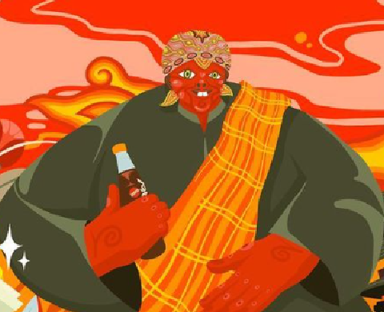

Figure 2. The Cepot icon in the  West Java and DKI Jakarta editions of the 75th Indonesian Independence Day

(Source: Instagram [**potr___**](https://www.instagram.com/potr___)10 July 2023)

Landmark Gedung Sate



Figure 3. Gedung sate icon in the  West Java and DKI Jakarta editions of the 75th Indonesian Independence Day

(Source: Instagram [**potr___**](https://www.instagram.com/potr___)10 July 2023)

Kendang from Sunda



Figure 4. Kendang icon in the  West Java and DKI Jakarta editions of the 75th Indonesian Independence Day

(Source: Instagram [**potr___**](https://www.instagram.com/potr___)10 July 2023)

Megamendung



Figure 5. Megamendung icon in the  West Java and DKI Jakarta editions of the 75th Indonesian Independence Day

(Source: Instagram [**potr___**](https://www.instagram.com/potr___)10 July 2023)

2. Cultural Values ​​of DKI Jakarta are represented by:

Monas Landmark



Figure 6. Monas icon in the  West Java and DKI Jakarta editions of the 75th Indonesian Independence Day

(Source: Instagram [**potr___**](https://www.instagram.com/potr___)10 July 2023)

Tari Topeng betawi

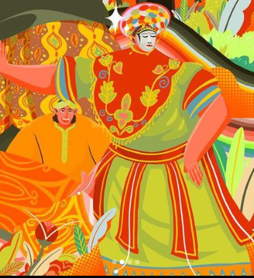

Figure 7. Tari topeng Betawi icon in the  West Java and DKI Jakarta editions of the 75th Indonesian Independence Day

(Source: Instagram [**potr___**](https://www.instagram.com/potr___)10 July 2023)

Through illustrations in the form of icons, landmarks and symbols from West Java and DKI Jakarta, Teh Botol Sosro presents a different appeal in establishing relationships and communicating with consumers. The following are the stages of packaging design that can be connected::

1. Revive local identity, with the cepot icons, the satay building, the Betawi mask dance, and monas being symbols of the regions of West Java and DKI Jakarta. Through these elements on the packaging will make consumers feel close to the culture and heritage of the area.
2. As the Actualization of History and Tradition. The cepot is a character in traditional Sundanese art, which has a rich history and artistic roots. The Betawi mask dance has indirectly been eroded by civilization and modernization, reducing public interest in seeing the dance. With that, Teh Botol Sosro wants to revive history and traditions, which can attract local people to at least find out about this culture

3. Introducing an iconic location – through the cultural icons and symbols constructed on the packaging can increase a sense of pride in the area.

4. Generating a sense of care for local culture - through icons and symbols of local culture, people who still need to learn about the richness of Indonesian culture, especially West Java and DKI Jakarta, are expected to care more about local culture. In comparison, people who already know are expected to be able to contribute to developing and preserving the existing culture. So that cultural diversity can be maintained.

1. **Sensory experience (sensation)**

Packaging is a communication medium based on visual senses as an effort to attract consumer interest. Teh Botol Sosro currently does not only sell packaged tea drinks but also provides a sensory experience to consumers by displaying unique edition designs.

Wrapped in various cultures, especially West Java and DKI Jakarta. The illustration becomes a touch point, which illustrates the difference between the Teh Botol Sosro product and competitors of similar tea drinks. Klimchuk and Korasovec argued that “touch point is a linking brand strategy with consumers and visually easy to identify” (Klimchuk & Korasovec, 2007, p. 121).

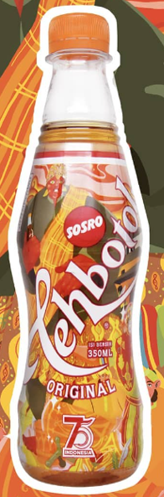

Figure 7. Visualization of packaging for the West Java and DKI Jakarta editions of the 75th Indonesian Independence Day

(Source: Teh Botol Sosro 10 juli 2023)

In addition to illustrations, colour can be used as a packaging communication medium. Colour is a visual aspect that the human eye sees and is closely related to light. In visual communication, colour has an important role; Color can produce emotions and a person's perception of the object he sees. As Humphrey wrote in Klimchuck and Krasovec, "the human ability to see colour indirectly continues to grow and evolve to meet the needs of his life" (Klimchuck and Krasovec,

2007: p.106). The visualization of the Sosro Bottle Tea packaging for the 75th Indonesian Independence Day editions of West Java and DKI Jakarta is dominated by Orange, Red and Brown colours. This is interesting to identify because, psychologically, colour can affect consumer perceptions of the Sosro Bottle Tea product. In line with this, Wicaksono, Marindra, and Kristianto stated that "colour can change feelings, influence perspectives, affect the atmosphere and provide identity" (Wicaksono et al., 2013).

Table 1. Psychology of Color

|  |  |
| --- | --- |
| **Color** | **Color psychology** |
| Red | Strength, Energy,  Warmth, Leadership, Respect, |
| Orange | Warmth, Passion, Balance, Storytelling, Enthusiasm, Interesting |
| Brown | Land, Earth, Tradition, Wealth, Depth, Calm |
|  |  |
|  |  |

Psychologically, it can be concluded that these colours are implemented in the Teh Botol Sosro packaging. From the theme of independence, the red colour indirectly represents Indonesian independence.

**c.  Imagination**

At this stage, communicating through imagination is how the ability of a brand brings creativity and a different appearance to attract consumers. The West Java and DKI Jakarta editions of the Teh Botol Sosro Indonesian Independence Day give imagination through the illustration style. The use of this illustration is in line with the trend in 2020, where the technique used is to enlarge certain parts so that they do not match the original proportions.Apart from following trends, this is also done as part of a design contribution to triggering consumers' imaginations and can also generate curiosity about these characters.

**d. Interaction**

Vision is one of the factors for product success in the long term, and this factor is supported by the company's tools, which help maintain consumer emotional resonance for the Teh Botol Sosro product, especially the West Java and DKI Jakarta editions. In this case, Teh Botol Sosro not only invites the public to enjoy the packaging designs displayed, but until now, Teh Botol Sosro invites consumers to be directly involved in preserving culture and being proud of the nation's culture through its campaign, namely #Localunite. This is done so that consumers' emotional closeness to the product can continue and not just stop at the packaging of the 75th Indonesian Independence Day.

**CONCLUSION**

In this study, the authors have analyzed the concepts and themes in the visual packaging of Teh Botol Sosro for the 75th Indonesian Independence Day editions of West Java and DKI Jakarta. Using the right concepts and themes in a branding strategy can help increase product sales and create an image following what the company wants for consumers. Therefore, a theme and concept are essential in the current market competition.

Teh Botol Sosro applies the theme of independence and Indonesian cultural diversity in creating a solid emotional bond between products and consumers. Using icons, cultural symbols and the spirit of independence can inspire a sense of nationalism and community pride. This approach increases product appeal, strengthens product identity, and builds deeper community relationships. Attractive packaging visualization plays an important role the formation of lasting bonds between brands and consumers.

**BIBLIOGRAPHY**

Abrar, A. N. (n.d*.). Memeberi Perspektif Pada Ilmu Komunikasi*. Jurnal Ilmu Sosial dan Ilmu Politik, Vol. 6, 187-201.

Baldwin, J., & Roberts, L. (2006). *Visual Communication From Theory to Practice*. AVA book.

Begrer, A. A. (2010). *The Object Of Affection.* Palgrav Macnil.

Gobe, Marc. (2005) *Emotional Branding : Paradigma Baru Untuk Menghubungkan Merek Dengan Pelanggan.* Jakarta. Erlangga.

Nastain, M. (2017). *Branding dan Eksistensi Produk (Kajian Teoritik Konsep Branding dan Tantangan Eksistensi Produk)*. CHANNEL, Vol.5,(April), hal. 14-26.

Palupi, D. R. (2017). *Analisis Tanda Visual Kesucian melalui Pendekatan Semiotik: Studi kasus Kartu Imlek, Natal dan Idulfitri*. Tesis Pascasarajana ITB

Rahardjo, S. T. (2019). *Desain Grafis Kemasan UMKM*. CV Budi Utama

Raposo, D. (2022). *Design, Visual Communication and Branding*. Cambridge Scholars Publishing

Soewardikoen. D.W. (2020) *Metodelogi Penelitian Desain Komunikasi Visual*. Yogyakarta. Kanisius

Sugiyono. (2016). *Metode Penelitian Kuantitatif, Kualitatif dan R&D*. Alfabeta

Supriatna. (2021*). Komunikasi visual kemasan mie instan varian heritage Nusantara. Bandung*. Sunan Ambu Press

Travis, D. (2000). *Emotional Branding: How Successful Brands Gain the Irrational Edge*. Prima Venture.

**Journal Article**

Wicaksono. Marindra. Kristianto (2013) *Komposisi Warna Website Universitas Kelas Dunia, Studi Kasus Harvard University, University Of Cambridge Dan National Taiwan University*. UPN.

Rachmawati, R., & Sawitri, S. (2015). *Implementasi Strategi Branding Usaha batik dan Pengaruhnya terhadap Prilaku Konsumen dan Loyalitas Konsumen Pada UMKM Batik Pekalongan Jawa Tengah*. TEKNOBUGA, Vol. 2 No.1, Hal. 19-

Riyadh. Faisal & Fahmi (2022) *Memperkenalkan Tokoh Punakawan Pada Anak Usia 4-5 Tahun dengan buku Ilustrasi Interaktif*. KREATIF Vol. 4 No. 2 Desember 2022

**Audio/Video**

Teh Botol Sosro. 2020. *Delapan Kemasan dengan Desain Khusus Karya Ilustrator Muda.* <https://www.youtube.com/watch?v=i5RRikg_0jQ>

Webinar, Jalur Rempah RI (2021) *Rempah dan TheNusantara.* https://www.youtube.com/watch?v=KevDDVeyFn4 (diakses juni 2023)

Webinar, Fsrd UNES (2021), M*eta Statis – Budaya Visual.* (diakses juni 2023)

**Webiste**

Nugraha, W. D.2020. *Mensyukuri Kemerdekaan dalam Selembar Rupiah.* RetrievedAgustus 18, 2023, from https://www.kompas.id/baca/ekonomi/2020/08/18/mensyukuri-kemerdekaan-dalam-selembar-rupiah

*Pepsodent Luncurkan Pepsodent Edisi Spesial untuk #merdekakanSenyum Keluarga Indonesia. Retrieved* Agustus 10, 2023, from <https://www.kompas.id/baca/ekonomi/2020/08/18/mensyukuri-kemerdekaan-dalam-selembar-rupiah>

Precious, Communications. .2020. *Cara Brand Memenfaatkan momentum kebangkitan dan Ketangguhan Indonesia Pada 77 Tahun Kemerdejaan sebagai Bentuk Konstinuitas Komunikasi.* RetrievedAgustus 2, 2023, from <https://www.preciouscomms.com/cara-brand-memanfaatkan-momentum-kebangkitan-dan-ketangguhan-indonesia-pada-77-tahun-kemerdekaan-sebagai-bentuk-kontinuitas-komunikasi/>

Ulya. N. F (2020). Uang Rp.75.000 Edisi Hut RI Resmi Dilanuncurkan, Dicetak Hanya 75 Juta Lembar. Diakses pada 10 Juni 2020